
UK launch of the Electronic Literature Collection Volume 1

Thursday 17th May 2007, 6.00pm - 7.30pm at The Institute of Creative Technologies, De Montfort University, Leicester, UK
(doors open at 5.30pm for drinks)

For directions please visit www.ioctsalon.com/directions.htm

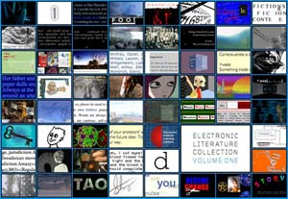
This event is free of charge and open to the public. The first 50 audience members will receive a complimentary copy of the ELC Volume 1.
The Electronic Literature Collection Volume 1 is an eclectic anthology of sixty works in a variety of styles and formats, from hypertext to Flash poetry, that represents a broad spectrum of electronic literature published between 1994 to 2007. It was published by The Electronic Literature Organization and edited by N. Katherine Hayles, Nick Montfort, Scott Rettberg and Stephanie Strickland.
Guests at this Salon will include:

- Scott Rettberg (http://retts.net, writer, co-editor of ELC Volume 1, co-founder and first executive director of the Electronic Literature Organization)

and the UK-based writers who feature on the ELC Volume 1, who will show their work and discuss what Electronic Literature means for them:

- John Cayley [ http://www.shadoof.net/in/ ]
- Jon Ingold [ http://www.ingold.fsnet.co.uk ]
- Chris Joseph [ http://www.chrisjoseph.org ]
- Kate Pullinger [ http://www.katepullinger.com ]

"...this is an essential collection. Anyone interested in the field of electronic literature should take the trouble to get it on DVD. Some of this material is priceless, and it may not be available on the Web indefinitely." - Edward Picot, The Hyperliterature Exchange

The IOCT Salon [ www.ioctsalon.com ] is managed by Chris Joseph, Digital Writer in Residence at the Institute of Creative Technologies, De Montfort University. This residency is funded by Arts Council England: East Midlands. For further information about the IOCT Salon please email Chris at info@ioctsalon.com

The IOCT Salon is held at and staged by and supported by






